Pythagorean Triples!

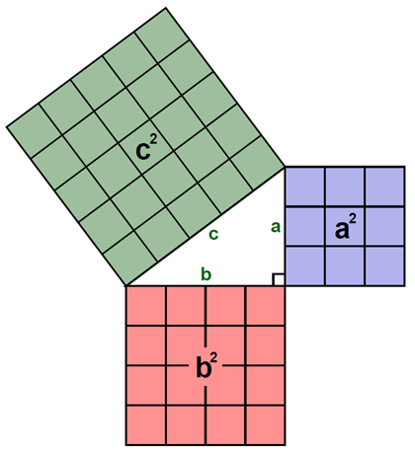
a  leg | b  leg | c  hypotenuse | Area of square with side length a  = a² | Area of square with side length b  = b² | Area of square with side length c  = c²
3 | 4 | 5 | 9 | 16 | 25
6 | 8 | 10
9 | 12 | 15
5 | 12 | 13
10 | 24 | 26
15 | 36 | 39
8 | 15 | 17
16 | 30 | 34
24 | 45 | 51
7 | 24 | 25
14 | 48 | 50
21 | 72 | 75

Question: Is it true that a² + b² = c² in a right triangle? What if a² + b² > c²? What about if a² + b² < c²?

